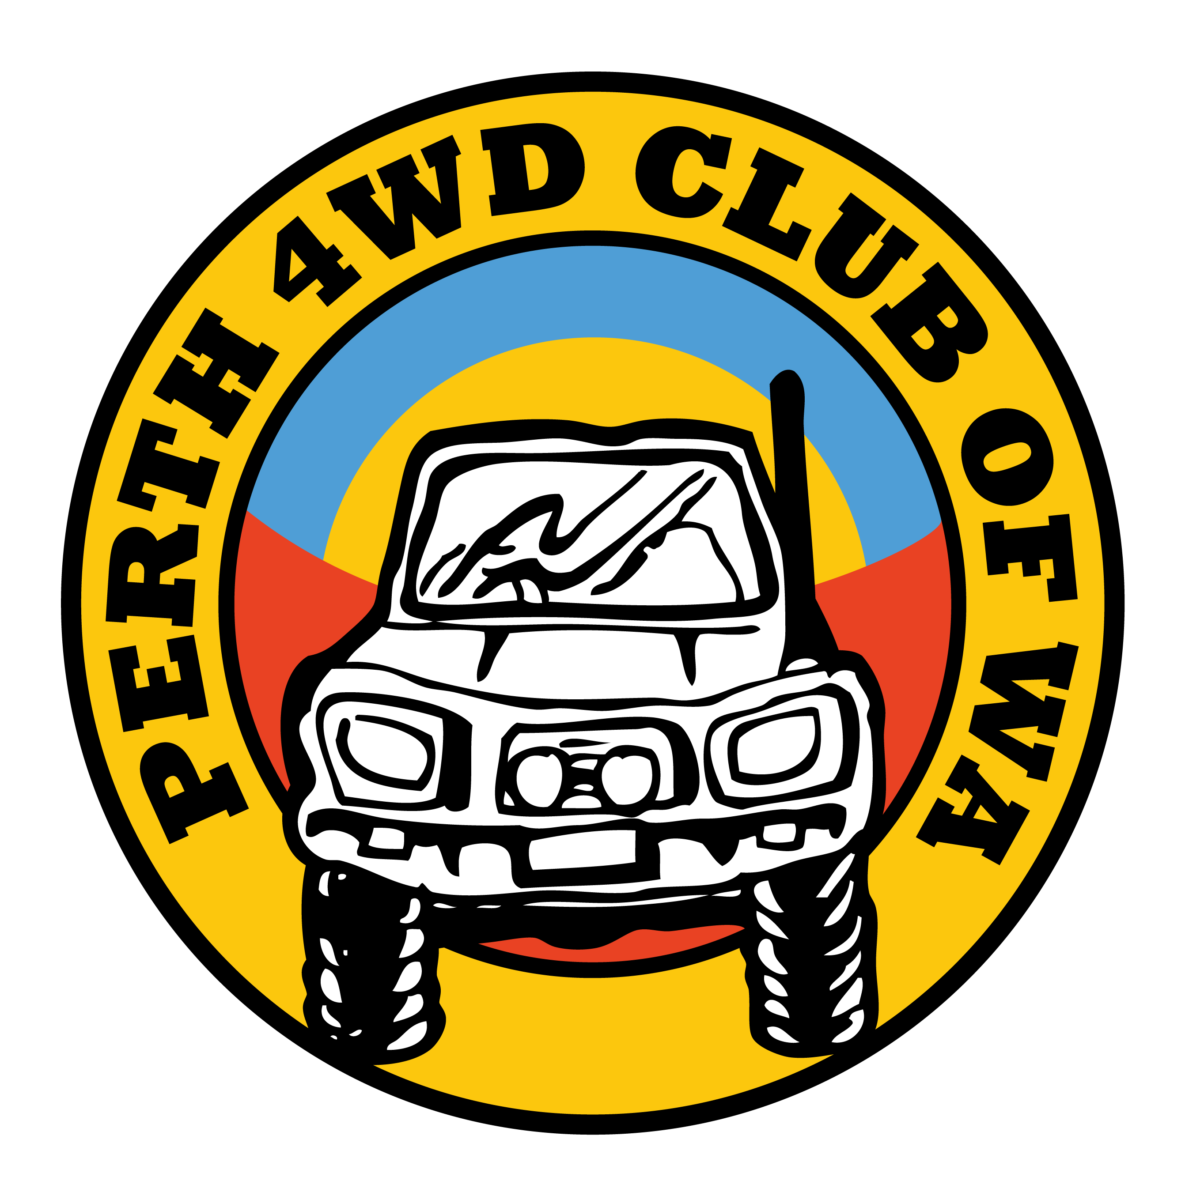

TEMPORARY MEMBER/VISITOR –
TRIP PARTICIPANT FORM

This form should be completed for all club trips when a temporary member or visitor driving
their own vehicle attends a Club trip. Submit the completed and signed form to the Trip Leader.

TRIP ………………………………………….. DESTINATION ………………………………
DATE/S ……………………………………… TRIP LEADER ……………………………….

TEMPORARY MEMBER / VISITOR INFORMATION

NAME …………………………………………………………………………………………..
ADDRESS ……………………………………………………………………………………...
PHONE NUMBERS ………………………………MOB……………………………………
PASSENGERS …………………………………………………………………………………
…………………………………………………………………………………………………..
…………………………………………………………………………………………………..
VEHICLE MAKE …………………………………… MODEL …………………………………
REGISTRATION …………………………………….
Complete and sign separate Personal Details Form and hand it to the Trip Leader
1) As a temporary member/visitor you are representing the Perth 4WD Club of WA of the WA4WDA and are expected to
abide by our Rules and By-laws. If you are not familiar with our Rules or By-laws please ask the Trip Leader to explain them
or give you a copy to read.
2) If you are not confident or do not wish to attempt any part of an event, it is your responsibility to inform the Trip Leader.
3) In the event of vehicle recovery, it is the vehicle owner's responsibility to approve recovery attachment points
and, where safe, to perform the attachment.
4) Safe driving practices must be adhered to at all times.
5) Please check with your vehicle insurer to ensure it has the appropriate level of cover.
6) Visitors may attend no more than two trips/events as a Temporary Member/Visitor prior to joining the Club.

SIGNATURE………………………………………………………. DATE……………………..

