Club Information
Come meet us and see what we are all about. Meetings are held every second Wednesday of the month at 7:45pm. (except January)

The location is at:

Victoria Park RSL
1 Fred Bell Parade
East Victoria Park

And afterward enjoy a nice cuppa to top off the evening.

Our monthly newsletter
provides you with information about all future and recent trips amongst other information.

How To Become A Member

Prior to becoming a member, visitors are required to attend 2 trips.

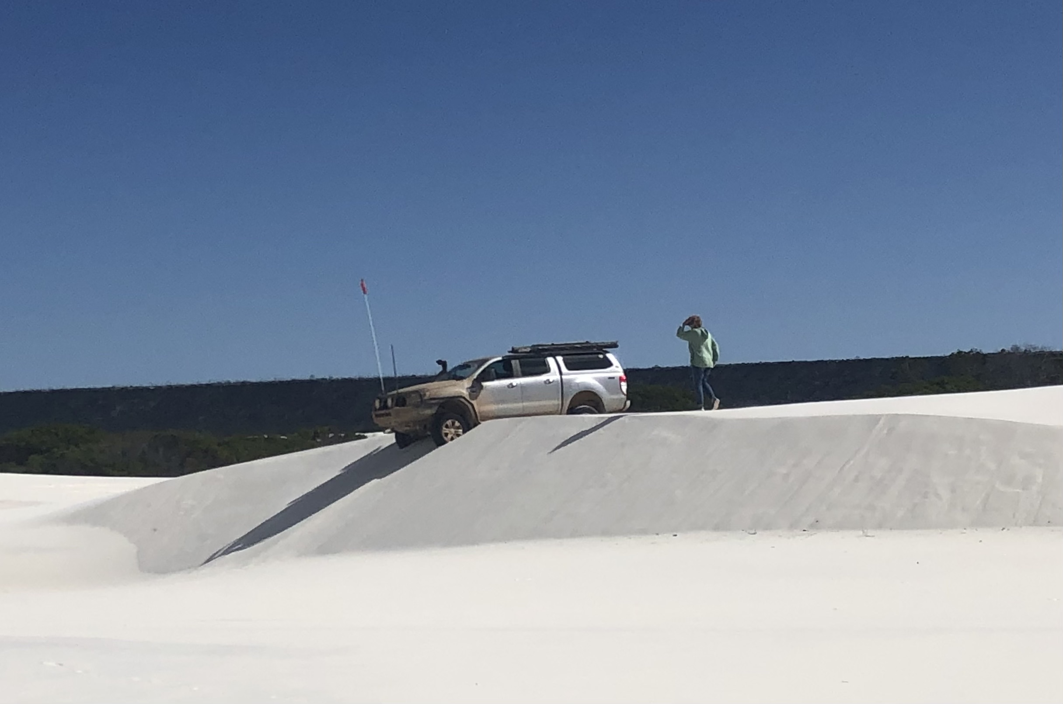
Contact Us

More information about our trips and upcoming events can be found at:

Website:

www.perth4wdclub.net.au

Email enquiries:

perth4wdclubofwa@gmail.com


Perth 4WD Club

Member of ARMA

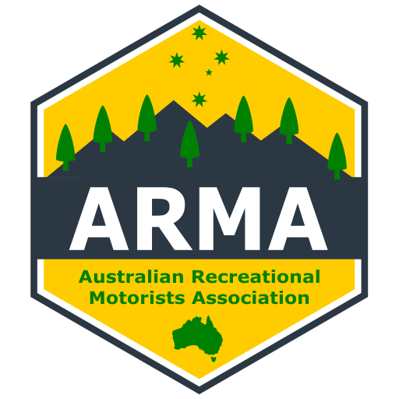

We support tread lightly on public and private land.

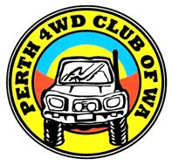

Providing 4WD and camping experience for over 40 years.

Enjoying the great outdoors

Respecting the environment

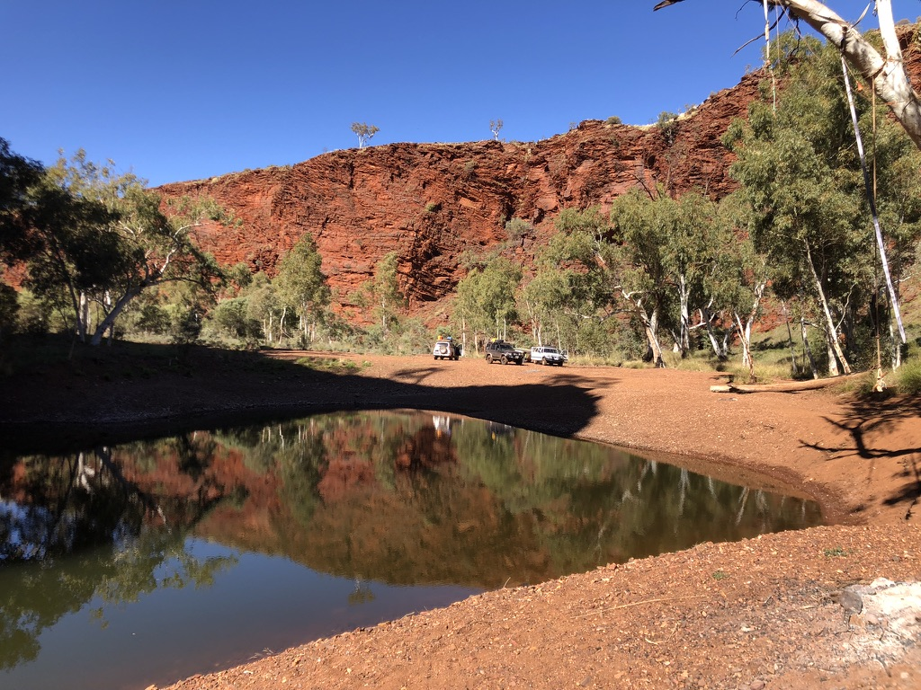

What We Do & Trips We Run
About Us

Extended Trips

Once or twice a year we also run longer trips up to a few weeks. These are adventure trips, exploring during the day and enjoying the evenings
around the campfire.
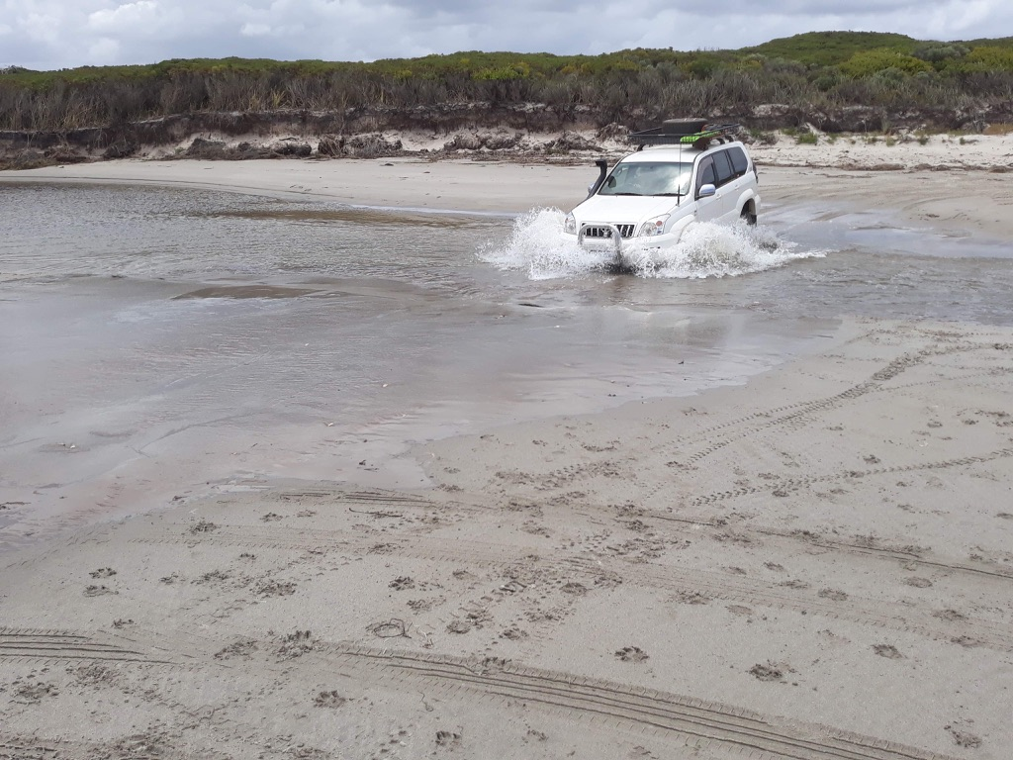
And Also……..

We are a family friendly club that had a dream to explore and has been operating since 1982.

We have been travelling throughout WA and Australia. Many of our members have lots of experiences in 4WDing and camping which they are willing to share.

We aim to provide an enjoyable 4WD and camping experience with like-minded people.
Whether you have done a little or a lot of 4WDing, everyone is welcome.

All ages, families and vehicles are welcome.
We provide a safe environment for beginners.

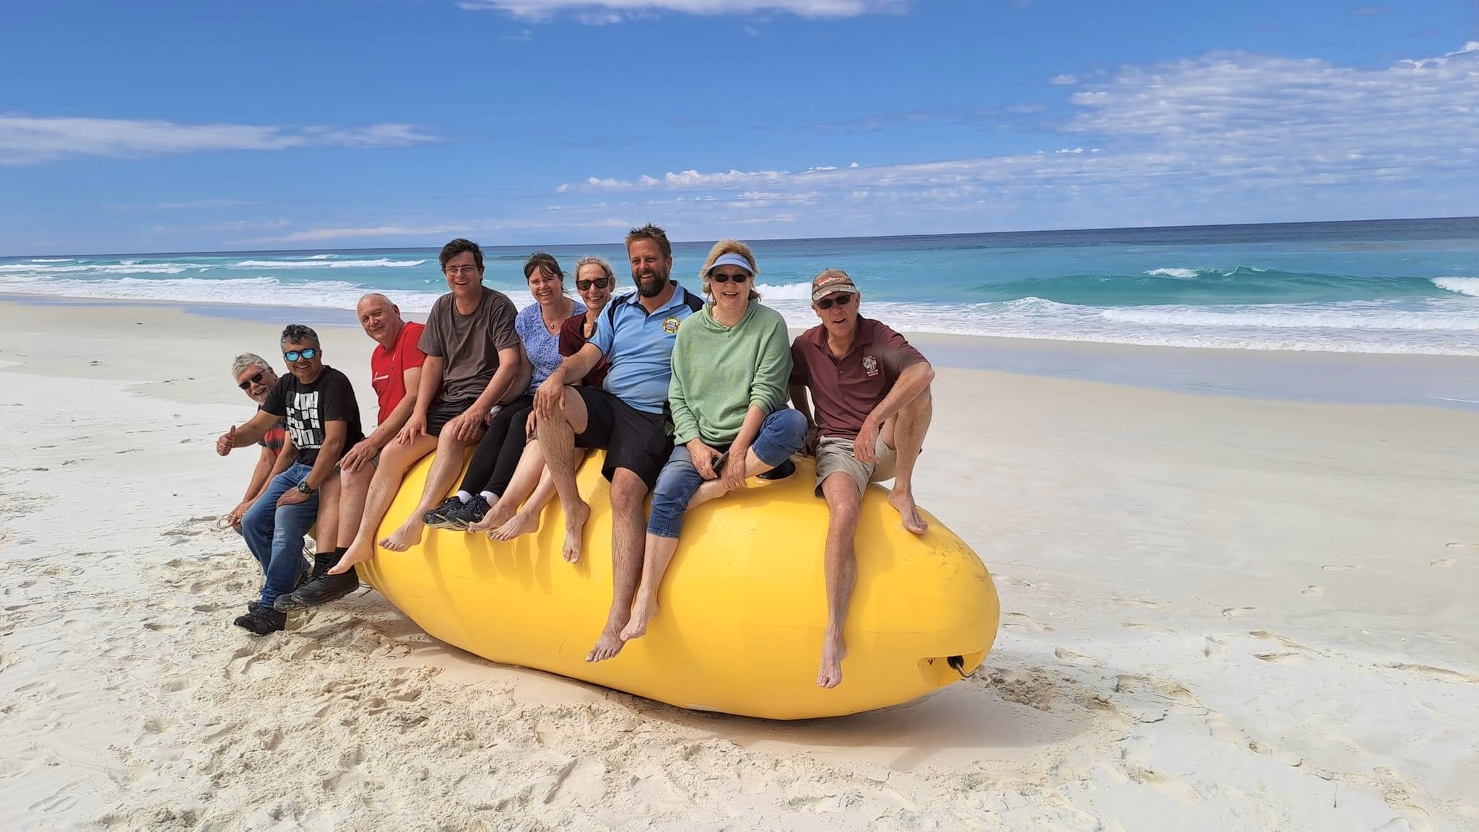

Day Trips

Our Day trips include 4WDing along beaches, sand dunes, forests and mud runs. They can vary from extreme to casual driving, exploring the hills and the greater Perth region.
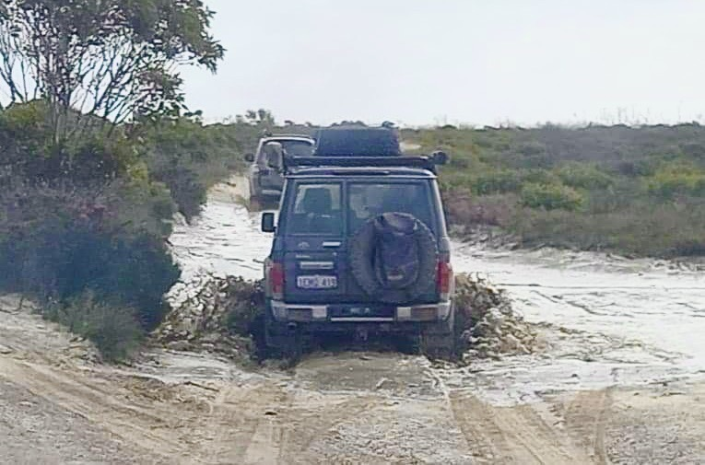

Weekend Trips

We also run weekend and
long weekend trips, camping in national parks or free camps. These are usually in beautiful bush settings.
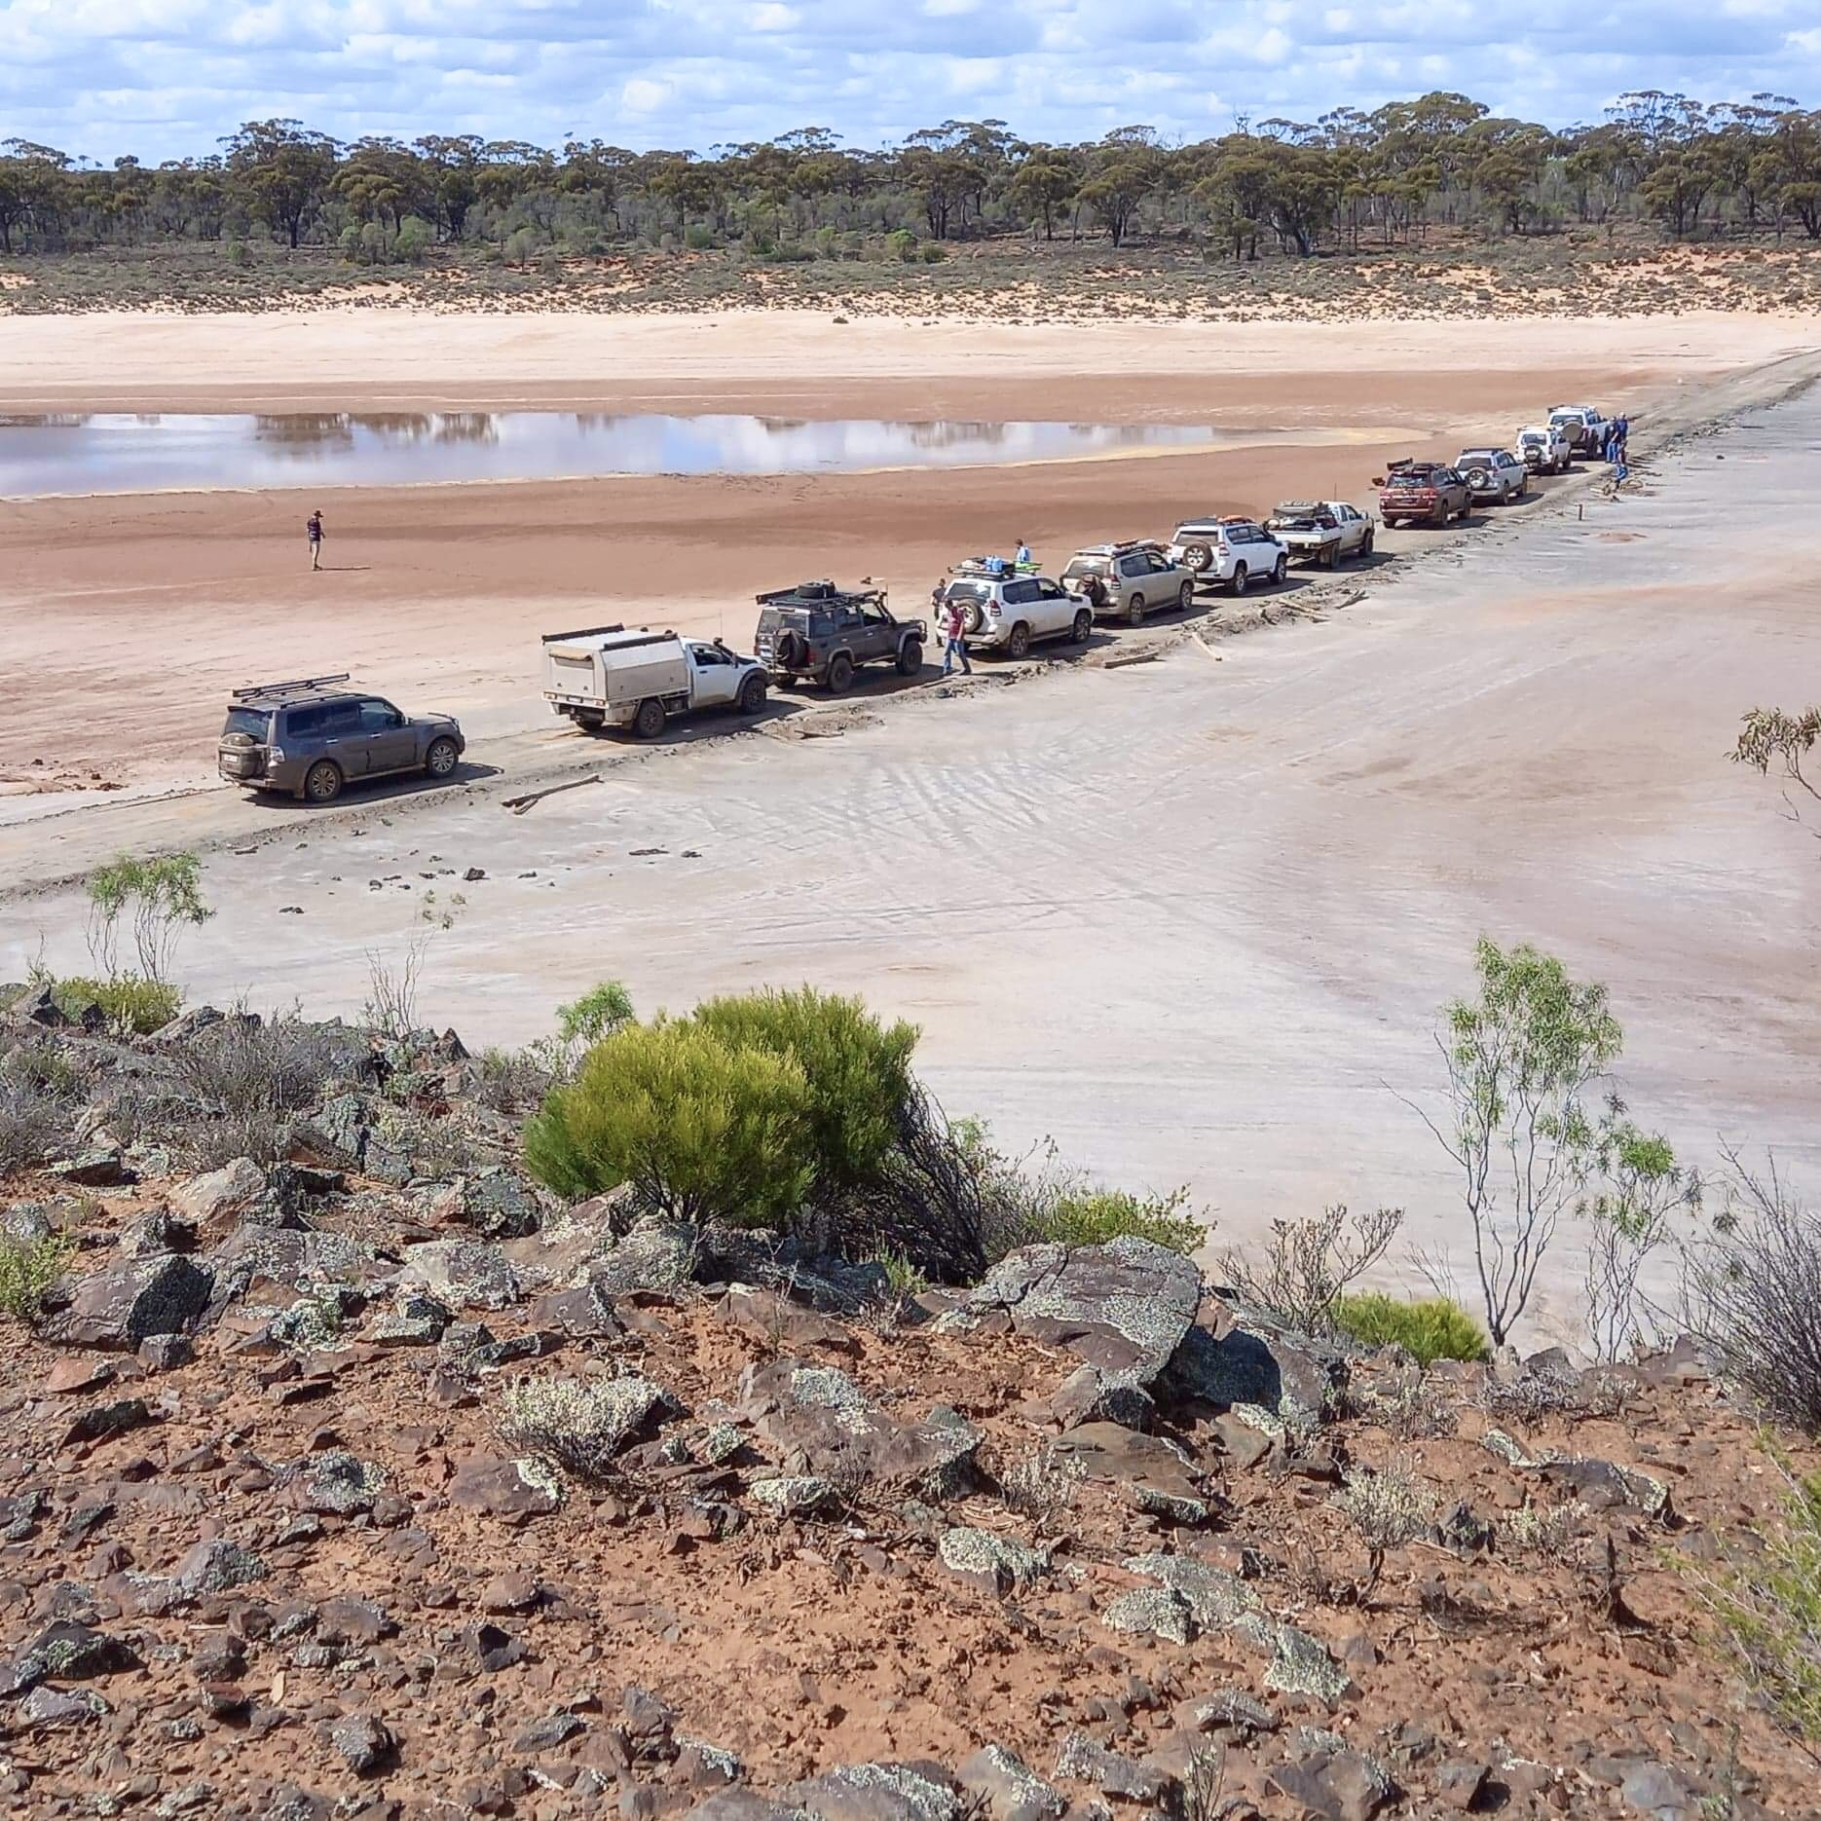
Social Events

Our social events include theatre nights,
golf days, trophy nights and
Christmas parties.

