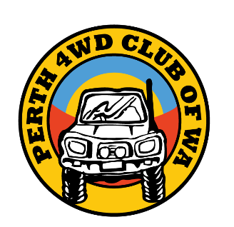
Perth 4WD Club By Laws
Version: 29th Oct 2025
Code of Ethics
- Members shall be prepared to conform to Majority decisions under the guidance of the Trip leader whose authority should be accepted at all times. Should it be necessary, a Trip Leader is empowered to recommend to the Committee of his Club that a member or members be banned from future trips or be asked to resign from the Club for refusal to comply with reasonable control.
- There shall be NO destruction of trees, shrubs or wildlife.
- All public and private property shall be respected, and no wilful trespass shall be permitted.
- Permission be obtained before entering private property.
- Every effort shall be made not to disturb stock where stock is present.
- Local water supplies must be respected.
- Express thanks for any help obtained from non-members.
- What is carried in should be carried out. (Rubbish, etc)
- All hygiene decisions shall be made by the Trip Leader.
  - At roadside stops the rule to be followed is: Ladies to the right, Gents to the left.
  - In all cases, paper, tissues and faeces must be buried.
  - Sanitary items must be disposed of appropriately.
- All gates are to be left as found.
- Every care shall be exercised in the lighting and control of fires and all fires shall be properly extinguished before leaving the area. NO fire shall be lit in prohibited areas or during prohibited periods.
- No member shall leave the convoy without letting the Trip Leader know they are leaving, if they are going to return and if necessary for rejoining the convoy, why and where they will be.
- All members shall comply with the requirements of the traffic Act and regulations. They must be courteous on roads at all times.
- The Trip Leader, or someone designated by him/her, shall keep a log of all happenings on the trip.
- Where livestock are present, all dogs are to be kept on a leash.
- At all turn-offs vehicles shall wait until the following vehicle is in view to see where to turn. The following vehicle may give confirmation by flashing the headlights or signalling over the Radio. Be aware of the vehicle behind you at all times.
- If a vehicle is delayed or in trouble, they should notify the others by radio so they can wait and/or send someone to help. No vehicle should be left in trouble without help.
- When travelling in convoy, vehicle position must be maintained with ample room between each other to allow other road users to pass through the convoy.
- No member shall have the right to invoke his club membership whilst on private trips.
- It shall be the responsibility of all members to ensure their vehicles are in sound mechanical condition and that adequate supplies of FUEL, FOOD and WATER are carried.
- No refuelling vehicles within 150 metres of camp.
- Members can take photos of trip participants except children under 12 unless with express parental permission. These may be shared on social and print media.
- The rights of other people to peace and solitude in the bush will be respected.
- It shall be the duty of every member to assist in keeping this code.
Temporary Membership
- An additional membership class will be called “Temporary membership”.
- This membership class is only entitled to:
  - Two club trips from grades 1 – 5 without subsidies where applicable.
  - Access to the private Facebook page.
  - The monthly Newsletter.
- Temporary members are required to fill in the Temporary Member/Visitor trip form when going on a trip.
- Trip leaders will need to download this form from the Website and print it in advance.

