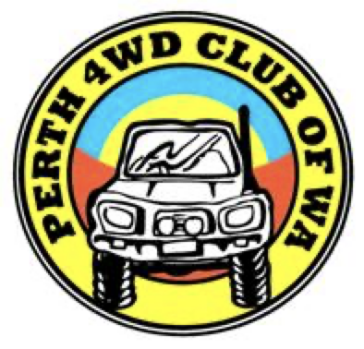

Welcome to the Perth 4WD Club of WA

As part of your membership you are now an ARMA member. This membership is insurance for property damage when you are out in the bush. (This doesn’t include personal property)

You now also will have access to our members Facebook group. In here you can see all the up upcoming trips and if you’re feeling confident, speak with the trip
co-ordinator about leading a trip and let him know where and when.

In your membership pack you will also see there is some helpful information about convoy travel, tyre pressures for road conditions and suggestions for your recovery kit.

Our meetings are once a month on the second Wednesday at 7pm. These are not compulsory but it does help to get to know other people in the club.

Our monthly newsletter will be emailed to you each month.

Also make sure you communicate with the merchandise manager for sizing on your
T-Shirt. There is also a club jacket available to purchase if you would like one.

Thank you for your interest in the club and your membership, we look forward to you joining us in the great outdoors.

Cheers

Perth 4WD Club

